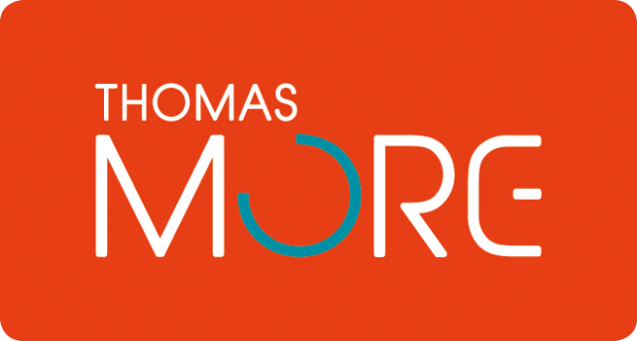

**PC refresh policy**

# Introduction

The "PC refresh policy" is necessary within an IT company. Of course we are not going to be able to renew our devices every 4-5 years for this project in the long term, but in principle that must be done within every professional company.

# Purpose of the policy

2.1 The purpose of this policy is to prepare and define a renewal policy for all IT equipment that is used. This allows staff to optimally use the devices with the latest software’s without impeding productivity. In addition, the high maintenance costs are prevented.

Outdated systems are also more vulnerable to external and internal attacks. As a result, we form a security policy (discussed in another section) to work as safely as possible.

2.2 The purpose of this policy is to minimize risk(s) from (but not limited to):

* Vulnerability of out-date or obsolete hardware and software systems to external and internal attacks
* In-adequate security and authentication functions for obsolete systems
* Unavailability of Security fixes and vulnerability patches for obsolete systems.
* The lack of technical support and defensive measures available to obsolete systems.

# Key factors

When evaluating the cost and value of upgrading, there’s a delicate balance to be found between direct IT costs, end-user costs, and productivity gains. With any upgrade, it’s important to account for the full business use case and IT support model for all devices, ranging from purchase, deployment, and IT administration to support, security, and disposal—and everything in between.

In this paper, we will review the four key decision factors that have the most significant impact. These factors include device age, intended device usage, the degree of user mobility, and how the device is managed.

• Device age – The age of the device can greatly impact user productivity and the need for IT resources, becoming an important factor in determining the right time to upgrade.

• Usage model – How an employee uses a device (primary or secondary usage) to accomplish work has a significant impact on required IT service levels and corresponding support costs.

• Employee mobility – How mobile an employee is can have a significant positive impact on productivity, yet there is also the added cost of maintaining and servicing mobile devices.

# Cost and Value Benefits Summary

After device upgrades, organizations experience a reduction in IT operating costs and improvements in user productivity. One of the goals of this paper is to map these business benefits to the three primary cost and value categories , as shown in the following table.

|  |  |
| --- | --- |
| **Cost/Value Categories** | **Business Benefits** |
| Direct IT costs | Organizations can lower costs to maintain new hardware; lower IT  help-desk support costs across all tiers of IT support services; and lower  security management costs. |
| End-user costs | Users spend less time troubleshooting new devices and software as  compared to older devices. |
| Productivity gains | Users gain valuable productivity from stronger system performance and  increased mobility |

# Five best practices

1. **Keep costs down and productivity up with a regular refresh cycle.**

With a proactive approach to device refresh, you can ensure

that the devices in your organization are maintained for an

appropriate length of time, avoiding the support costs and lost

productivity of aging devices. In most cases, devices will have

a useful life span of two to four years.

1. **Enable mobility.**

With better insight into workflow and how people use mobile

devices, it’s easier to determine the right tool for the job. By

integrating mobile devices into your enterprise environment,

you can drive productivity across your business while keeping

users happy.

1. **Reduce costs with a well-managed device model.**

With a well-managed device model, you can help reduce IT costs while increasing security and improving business efficiencies. Although mobile devices increase costs, these costs can be offset with a well-managed device model

1. **Use advanced technologies.**

By design, newer technologies are built to enable the mobile business. 4th generation Intel Core vPro processors deliver the remote manageability and security your business needs, with the performance and long battery life users want.

1. **Consider a 2 in 1.**

The 2 in 1 device is a tablet when users want it and a laptop when they need it, with convertible or detachable form factors that minimize the number of devices for users to carry and for IT to manage.

# Conclusion

This led us to the conclusion that all PCs needs to be renewed every 5 years. The costs will be covered by our company. Of course it is impossible for our project to purchase a new pc every 5 years but if we had a real company this would certainly apply

# Source reference

* E-Government National Centre . (z.d.). *Policy* [PDF document]. Geraadpleegd op 26 februari 2020, van <http://www.information.gov.bn/PublishingImages/SitePages/New%20Media%20and%20IT%20Unit/ICT%20Policy%20-%20IT%20Equipment%20Refresh%20Policy.pdf>
* Intel IT center. (z.d.). *Refresh Policy* [PDF document]. Geraadpleegd op 26 februari 2020, van <https://www.intel.com/content/dam/www/public/us/en/documents/white-papers/enterprise-mobility-pc-upgrade-strategy-guide.pdf>
* Lesley University. (z.d.). *Refresh Policy* [PDF document]. Geraadpleegd op 26 februari 2020, van <https://support.lesley.edu/support/solutions/articles/107843-computer-refresh-upgrade-policy->